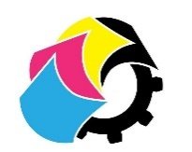
Perfect Bound Ltd – Your Print Consulting Partner!
🖨️ High-Quality Expert Consulting 🖨️
From business cards to banners, magazines to menus – we provide top-tier print solutions tailored to your needs. Let us handle the details while you focus on your business!
Our Services:
✅ Brochures, Flyers & Posters
✅ Business Cards (Matte/Gloss/Plastic)
✅ Custom Pull-Up Banners
✅ Stickers & Labels
✅ Magazines & Books
✅ Letterpress, Foiling & Die Cutting
✅ Eatery Menus, Loyalty Cards & More!
Why Choose Us?
✔️ Expert Print Consulting & Vendor Selection
✔️ High-Quality Materials & Custom Solutions
✔️ Competitive Pricing & On-Time Delivery
📍 Located in Pukekohe
📞 Call 027 454 3476
📩 philip@perfectboundltd.com
🌐 www.perfectboundltd.com
🔹 Let’s Bring Your Ideas to Life – Contact Us Today! 🔹
